

ÇANAKKALE ONSEKİZ MART ÜNİVERSİTESİ
BİLGİSAYAR MÜHENDİSLİĞİ
Nesneye Dayalı Analiz ve Tasarım Dersi

Proje Adı:
Lokanta Sipariş sistemi ( Restaurant Ordering System : ROSys )

Rapor 6:
- Report 4 diagrams correction for UC2
- Interaction Diagrams

Grup No: 06
Grup Adı: Firestone

Grup Üyeleri:
Amer Sawan (130401073)

Abdoul Karim Touré (130401078)

DANIŞMAN: Yrd. Doç. Dr. Ali Murat Tiryaki

Çanakkale 2017

Use Case 2: Process Payment
- System Sequence Diagram

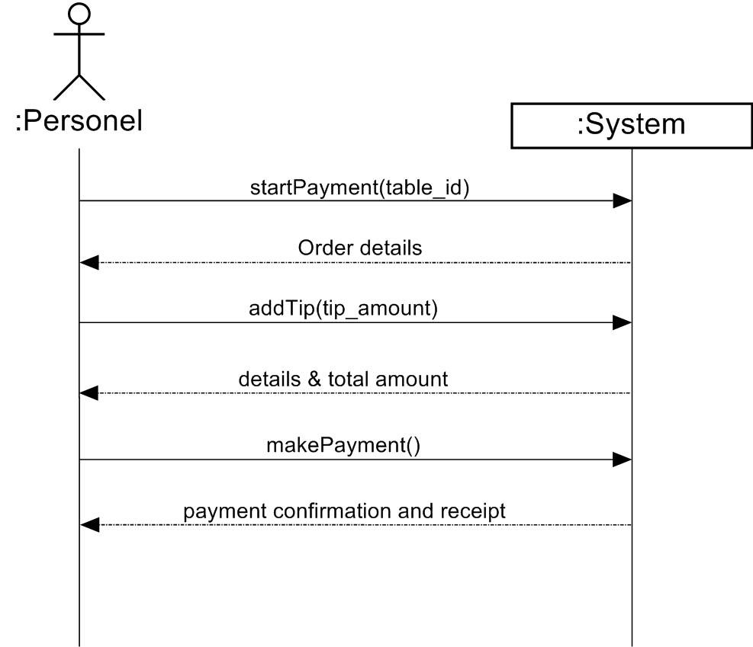

- State Machine Diagram

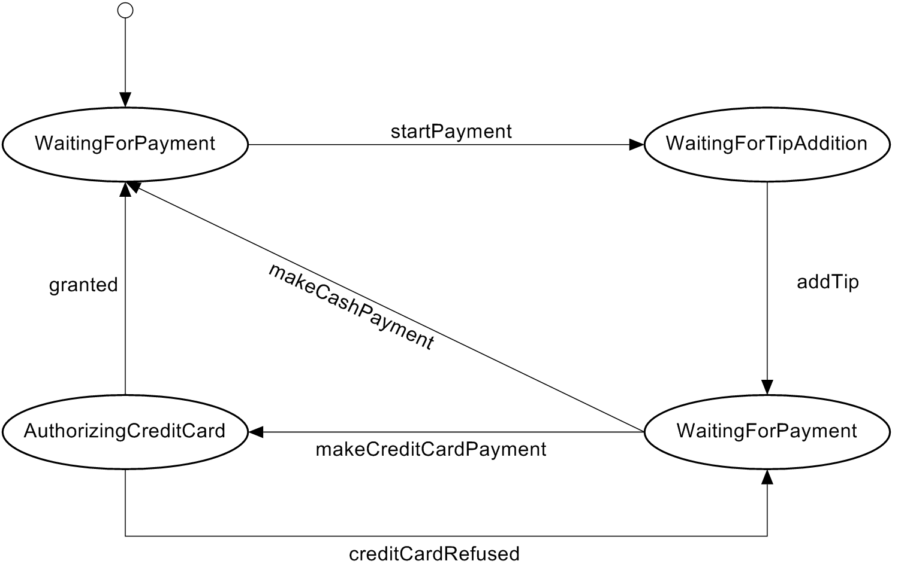

- Operation Contracts

Contract CO1: startPayment
Operation | startPayment(table_id)
Cross References | Use Case : Process Payment
Preconditions | none
Postconditions | - A Payment instance was created with name (p).  - The payment (p) was associated with the current ongoing order on the table associated with (table_id).

Contract CO2: selectOrder
Operation | addTip(tip_amount)
Cross References | Use Case : Process Payment
Preconditions | There is payment underway with name (p)
Postconditions | - p.tip_amount attribute became equals to tip_amount (parameter)

Contract CO3: makePayment
Operation | makePayment()
Cross References | Use Case : Process Payment
Preconditions | There is payment underway with name (p)
Postconditions | - p.isCompleted became true  - the current order attached to the payment p became associated with the Ledger instance.

Interaction Diagrams :
Use Case 1 :
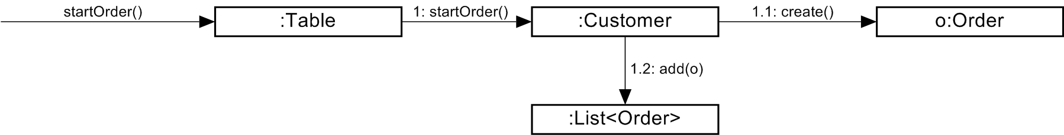

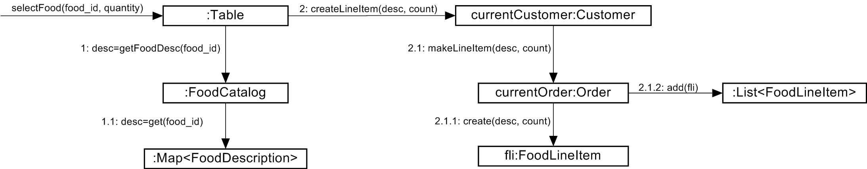

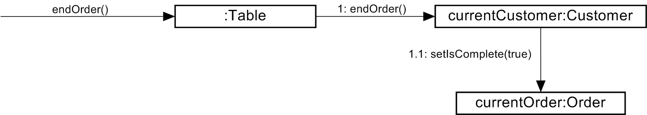

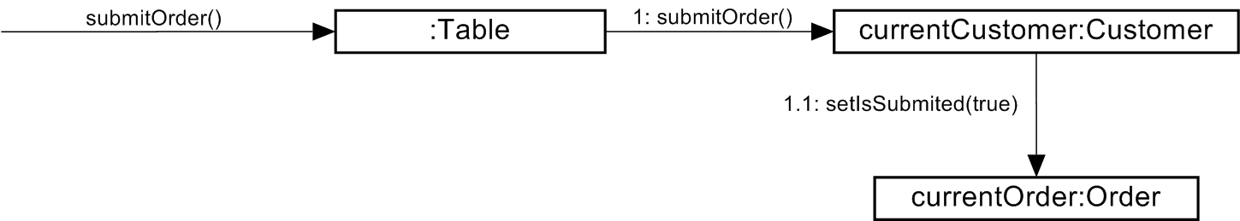
Use case 2 :
